Možeš preuzeti EMQX Open Source direktno sa službene stranice.
https://www.emqx.com/en/downloads-and-install/broker?utm_source=chatgpt.com

Najlakši način (Docker)
Za tvoj Digital Twin / SCADA projekt preporučujem Docker:
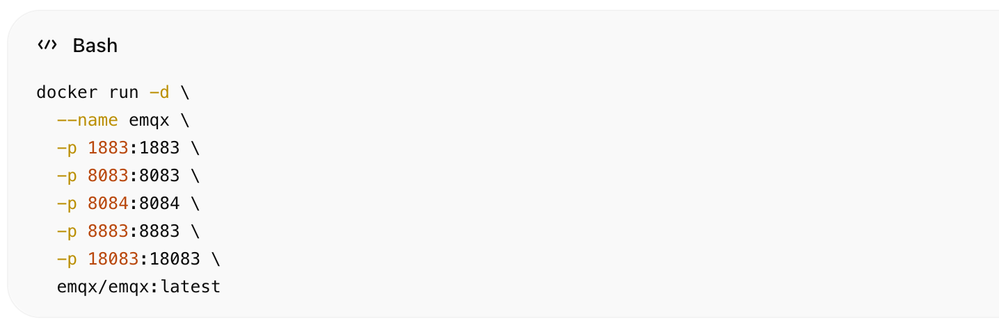
docker run -d \
--name emqx \
-p 1883:1883 \
-p 8083:8083 \
-p 8084:8084 \
-p 8883:8883 \
-p 18083:18083 \
emqx/emqx:latest

Nakon pokretanja
Dashboard:
http://localhost:18083
Default login:
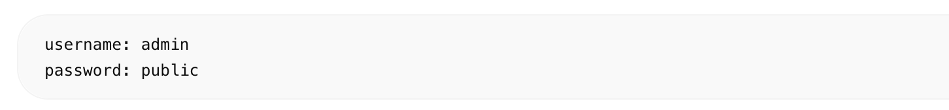username: admin
password: public

Native download (Linux / Windows / macOS)
Službeni download page:
EMQX Downloads
Tamo imaš:
- Docker
- Ubuntu/Debian
- RHEL/CentOS
- Windows
- macOS
- Kubernetes
- Helm charts

Za tvoj projekt preporučeni stack

Docker Compose
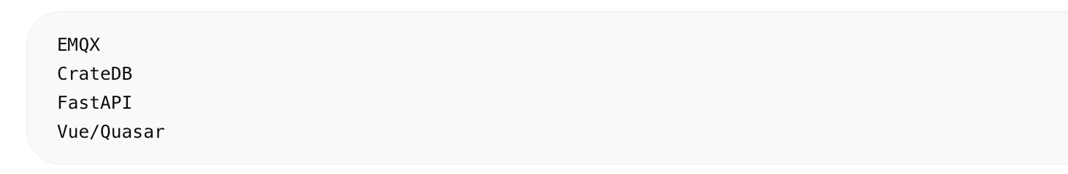
EMQX
CrateDB
FastAPI
Vue/Quasar

Preporučena verzija
Za stabilnost:
- EMQX 5.x LTS

Važni portovi
Port | Purpose
1883 | MQTT
8883 | MQTT TLS
8083 | WebSocket
18083 | Dashboard UI

Što dalje nakon instalacije
- Kreiraš MQTT topics:
trafostanice/+/sensors
- Spojiš Locust simulator
- Napraviš Rule Engine → CrateDB
- Vue/Quasar dashboard čita live podatke
- AI layer radi anomaly detection i forecasting

Korisni linkovi

Dokumentacija
EMQX Documentation

Docker Hub
EMQX Docker Hub

GitHub
EMQX GitHub
窗体顶端

窗体底端

